HW 15-TK-Hillel-BA IT-ENG-MVP and Roadmap

Определите набор функциональности по принципу MVP для вашего приложения на первые ТРИ фазы. Желательно использовать фичу, над которой вы работаете. Опишите в отдельном документе (можно вставить в СРС) либо дополните стори меп.

The following stories were selected for practicing purposes

Epic: Operations with user's account(s)

Requirement 1: Proceed money transfers between the user's accounts.

Requirement 2: Make transfers to Raiffeisen accounts.

Requirement 3: Make transfers to Raiffeisen cards.

Requirement 4: Transfer funds to accounts of other banks.

Requirement 5: Transfer funds to cards of other banks.

User Stories:

* As a bank customer, I want to be able to transfer funds between my accounts, so to be able to manage them directly in the application. ([Transfer between user's accounts](https://jira.ithillel.com/browse/ONBA1305-95))
* As a bank customer, I want to be able to transfer funds between my cards, so to be able to manage them directly in the application. ([Transfer between user's cards](https://jira.ithillel.com/browse/ONBA1305-96))
* As a bank customer, I want to be able to transfer funds between my account and a third-party account, so to be able to make transfers directly in the application. ([Transfer between user's account and a third-party account](https://jira.ithillel.com/browse/ONBA1305-98))
* As a bank customer, I want to be able to transfer funds between my card account and a third-party card account, so to be able to make transfers directly in the application. ([Transfer between user's card and a third-party card](https://jira.ithillel.com/browse/ONBA1305-99))
* As a bank customer, I want to be able to transfer funds between my account and a third-party RBA account, so to be able to make transfers directly in the application. ([Transfer between user's account and a third-party RBA account](https://jira.ithillel.com/browse/ONBA1305-100))

Story map view:

<https://miro.com/app/board/o9J_l6V3jM8=/>

or

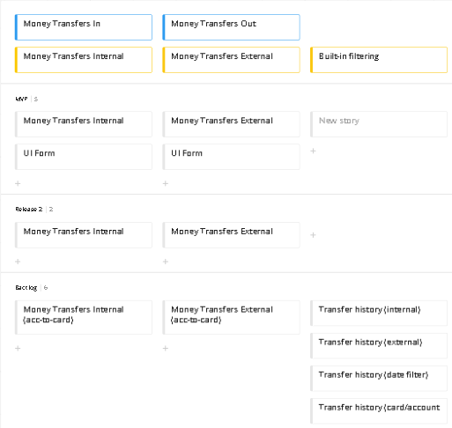

<https://drive.google.com/file/d/1fc3R5CLSPtE1hJqq0CO9J4Ki72REaUHA/view?usp=sharing>